FedRAMP Compliance for Log360 Cloud
Strengthen cybersecurity and meet FedRAMP compliance with Log360 .
Region: USA | Type: Cybersecurity Framework, Government/Public Sector, Industry Standard, Incident Management | Category: Compliance | Pricing: Free

Overview
The FedRAMP compliance extension in Log360 helps organizations meet the Federal Risk and Authorization Management Program (FedRAMP), the US government-wide security framework for cloud services based on NIST SP 800-53 by providing centralized log management, real-time threat detection, and automated compliance reporting. The platform supports FedRAMP requirements for account management, access enforcement, audit event generation, log review, configuration control, multi-factor authentication, incident response, vulnerability monitoring, and boundary protection across cloud and on-premise environments.
For AC-2 — Account Management and Lifecycle, Log360 monitors AD user management, group changes, and account lifecycle events to provide evidence of compliant account management processes across all systems. To address AC-3 — Access Enforcement, the platform monitors logon events, access attempts, and authorization changes across AD, Windows, and cloud services to verify access enforcement. The extension also supports AC-6 — Least Privilege Enforcement by providing capabilities that monitors privileged group changes, admin account activities, and elevated access events to detect privilege escalation and verify least privilege compliance.

Key Features
- AC-7 — Unsuccessful Logon Attempts: Log360 monitors failed logon reports across AD, Windows, Unix, and cloud services to detect brute-force attacks and verify lockout enforcement.
- AC-17 — Remote Access Monitoring: Log360 monitors terminal service sessions, VPN activity, and remote authentication events to verify compliant remote access practices and detect unauthorized remote connections.
- AU-2/AU-3 — Audit Event Generation and Content: Log360 collects comprehensive audit records containing event type, timestamp, source, outcome, and identity from all monitored systems.
- AU-6 — Audit Log Review and Analysis: Log360 provides automated audit log review, cross-source correlation, and anomaly detection to support the required weekly review cadence.
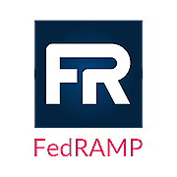
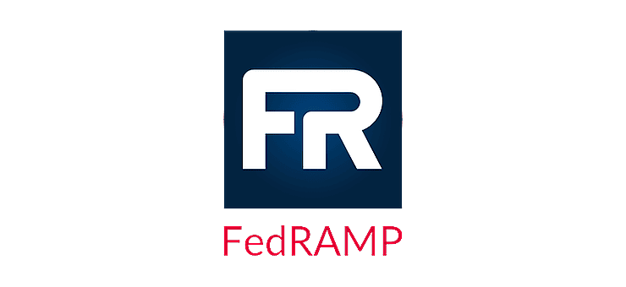
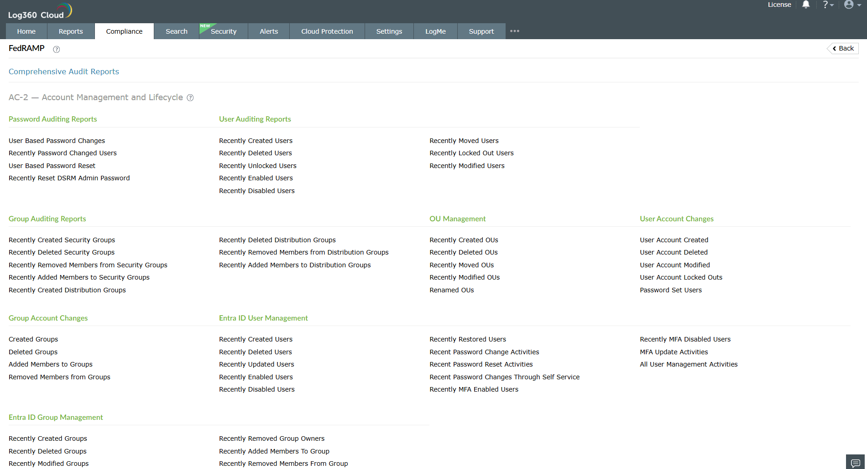
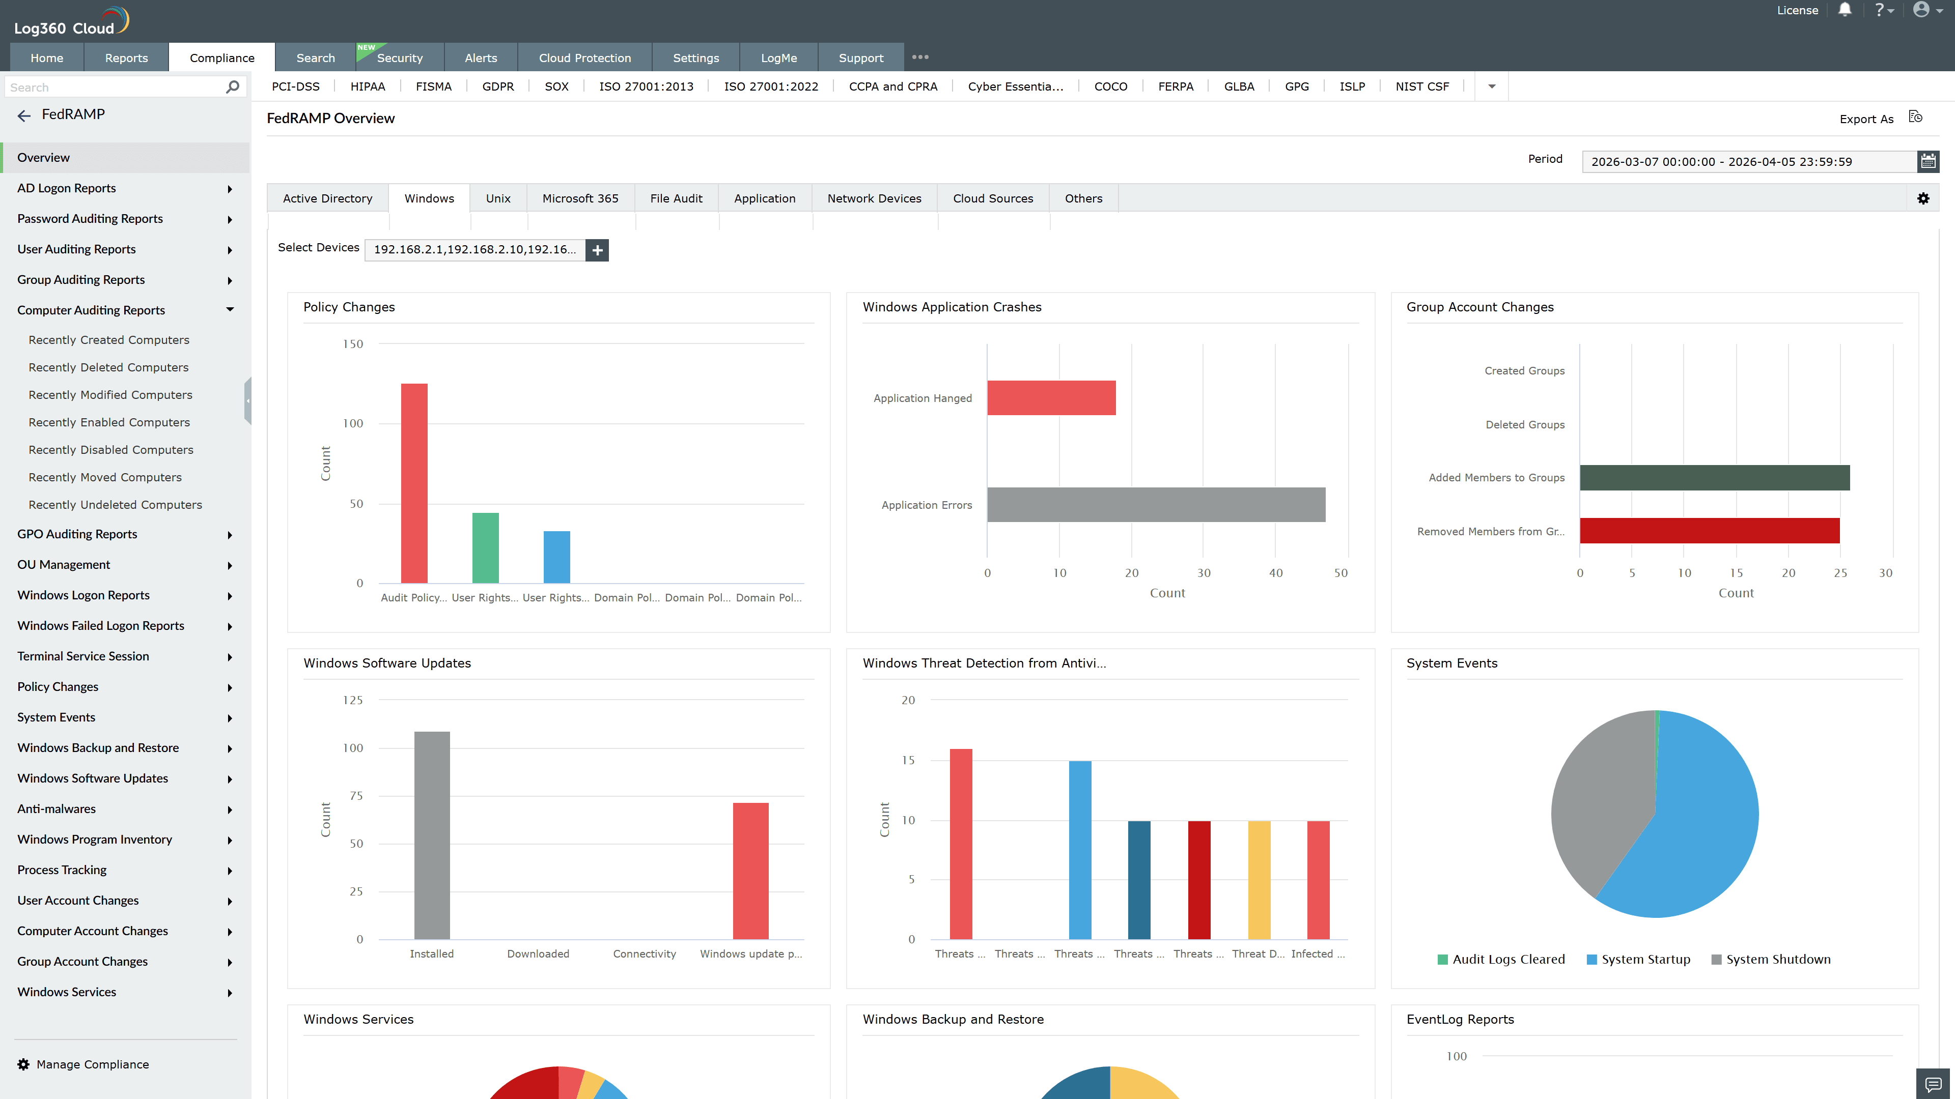
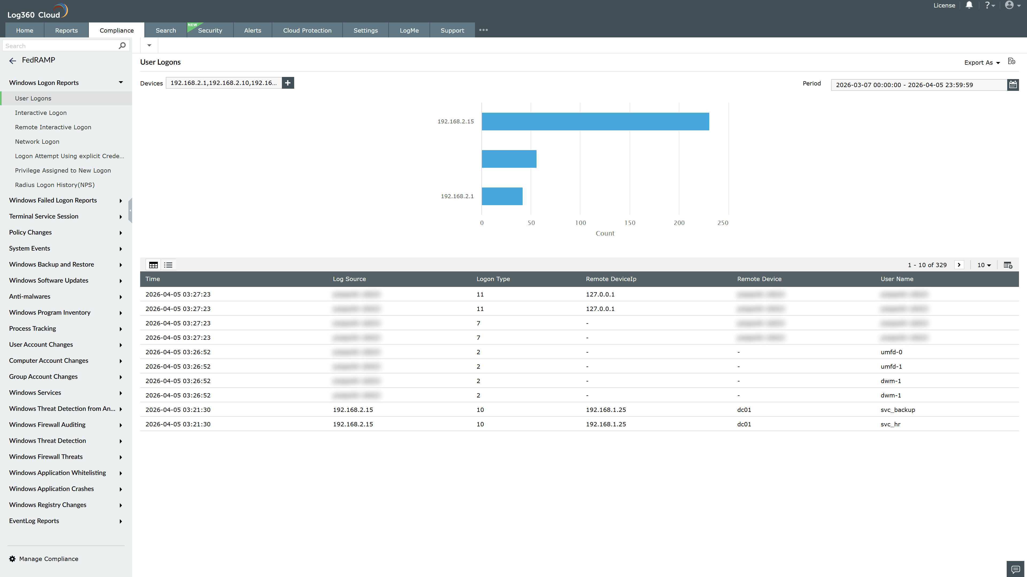
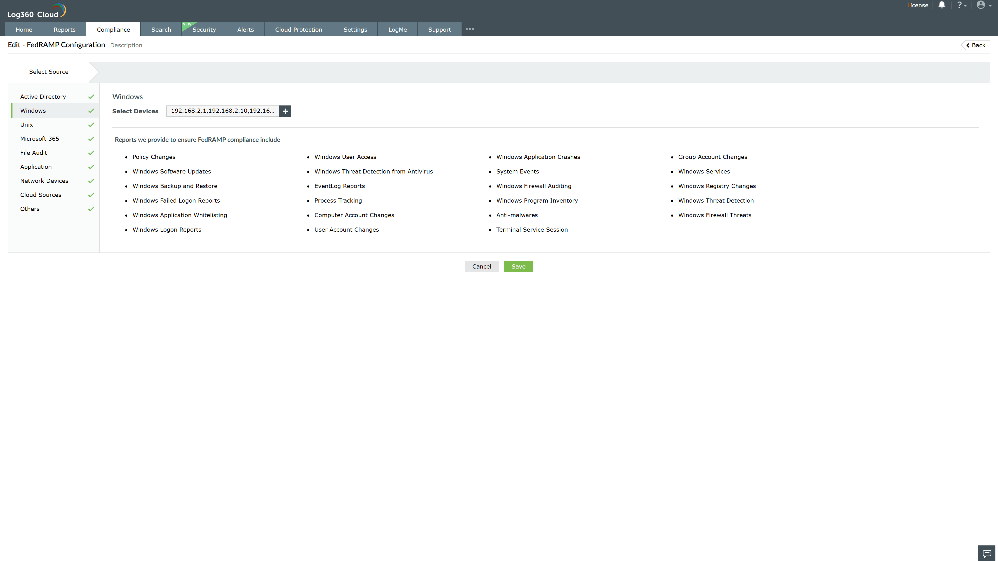
Valid Submission : Yes
Supported Editions : Free, Basic, Standard, Professional, MSSP
Help Document : https://www.manageengine.com/log-management/help/integrations/compliance-extensions.html
Help Video : Not provided
Tags : Log360 Cloud, Compliance, Privacy monitoring, Data privacy, Regulatory compliance
Supported DCs : US, IN, JP, CA, AU, UK and EU
Privacy Policy:
Terms of Service:
Release Notes:
Predefined reports for the FedRAMP.

